**Name: Hidy Refaey Saad**

**Group: 8**

**SEC: 46**

**P/N: 2**

**Subject:-**

**What is the Internet of Things? How the IoT works, and more**

**Screen shots:-**

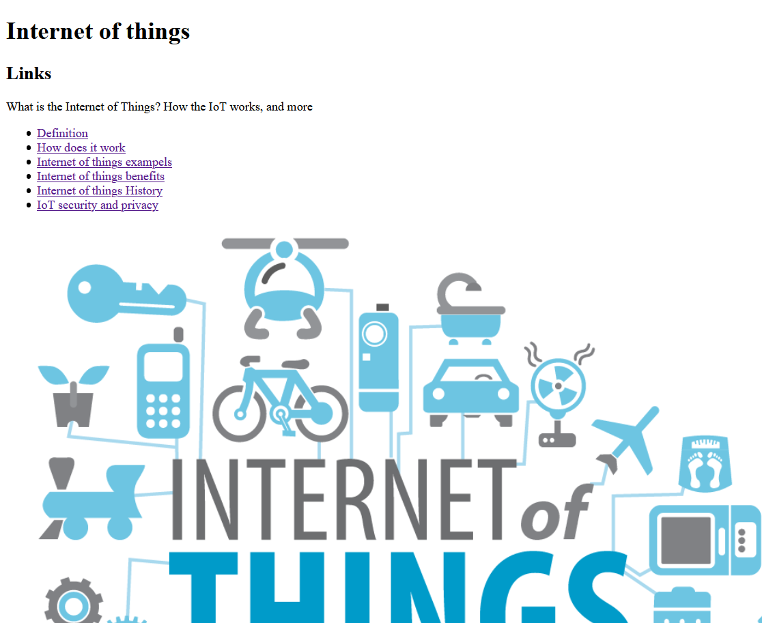

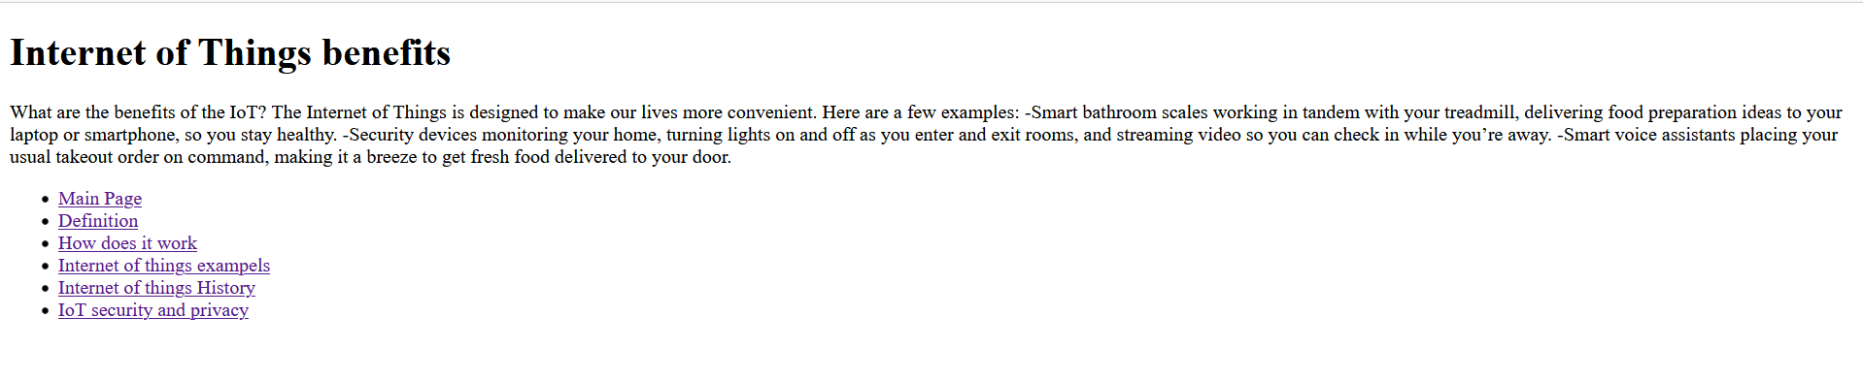

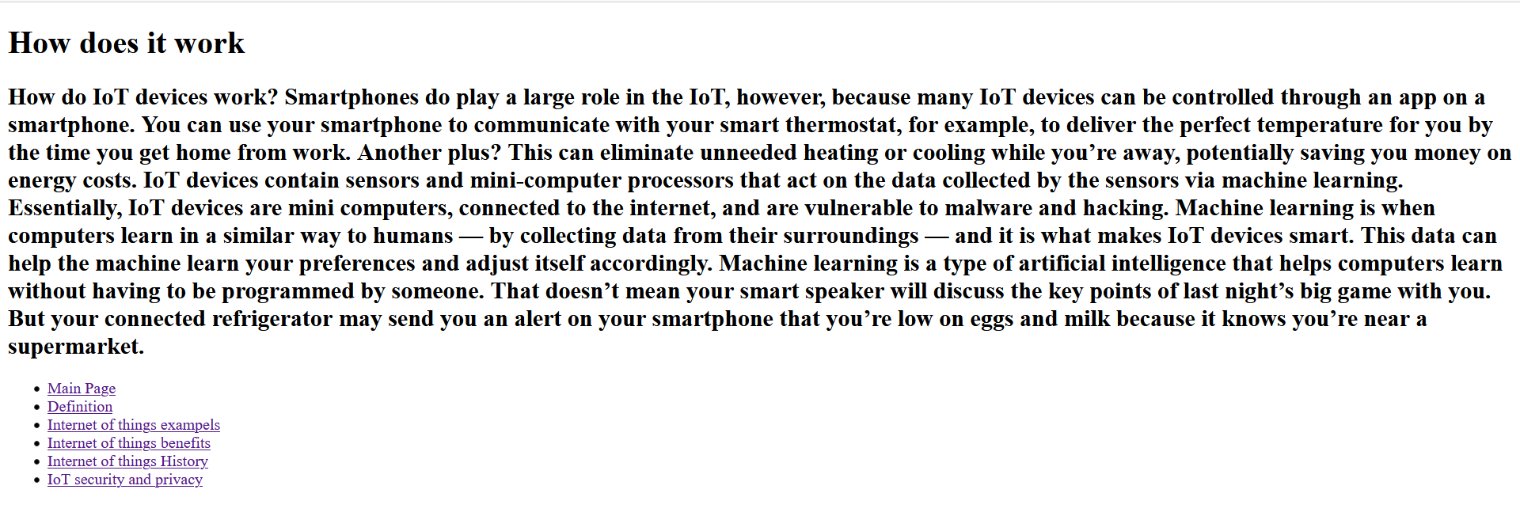

Source Code:-

